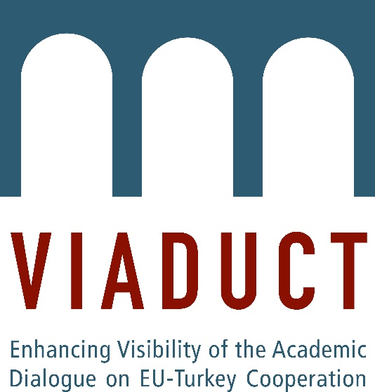

VIADUCT Student Paper Competition: Deadline 31 May 2018
VIADUCT is organizing a student paper competition that seeks excellent contributions on EU-Turkey relations and shall offer students the opportunity to gain experience with academic publishing. The aim of the competition is to contribute to the professionalization of very young researchers and to allow outstanding work by them to be recognised and widely disseminated. A committee of VIADUCT members will review the submissions and select the best papers for publication on the VIADUCT website.
Who can participate? Any student currently enrolled in an MA programme. Co-authored papers are also eligible. However, if one of the co-authors holds a PhD, they have to submit a letter attesting to the student's (students') pivotal role and contributions to the results.
What to submit? We are looking for excellent papers on EU-Turkey relations that discuss one of four possible themes: Power (Politics and Security), Resources (Economics and Energy), People (Migration and Identity) or the EU’s Future (e.g. impact of ‘Brexit’ on EU-Turkey relations). The papers must be written in English.
Length: 3000-3500 words (including bibliography)
Deadline: Email the paper to Dr Anna-Lena Högenauer (anna-lena.hoegenauer[at]uni.lu) by 31 May 2018.
The selection of the winning papers will be based solely on the quality of the submitted papers (and the extent of the students’ contribution to the paper in cases of co-authored papers). The best papers will be published in the online paper series at www.viaduct.uni-koeln.de.
For further questions, please contact Dr Anna-Lena Högenauer (anna-lena.hoegenauer[at]uni.lu).

